**CNN MODEL AFTER 2017**

**MobileNetV2(2018): A Lightweight and Efficient Deep Learning Model**

1. 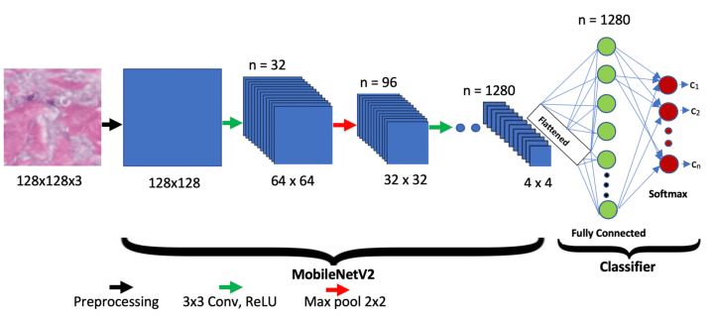**Introduction** MobileNetV2 is a state-of-the-art convolutional neural network (CNN) architecture designed for mobile and embedded vision applications. Introduced by Google in 2018, MobileNetV2 builds upon its predecessor, MobileNetV1, by incorporating novel techniques to improve accuracy and efficiency while maintaining a lightweight structure.

**2. Key Features of MobileNetV2**

* **Inverted Residuals and Linear Bottlenecks:** MobileNetV2 introduces an innovative approach where shortcut connections use lightweight depthwise separable convolutions, reducing computation while preserving accuracy.
* **Depthwise Separable Convolutions:** These convolutions reduce the number of parameters significantly compared to traditional convolutions, making the model highly efficient.
* **Efficient Network Design:** The model achieves a better trade-off between accuracy and efficiency by balancing network width and depth.
* **Reduced Computational Cost:** Designed for real-world applications, MobileNetV2 significantly reduces memory footprint and computational complexity compared to other deep learning models.

**3. Architecture of MobileNetV2** MobileNetV2 follows a streamlined architecture consisting of:

* A fully convolutional layer (initial feature extraction)
* A sequence of inverted residual blocks
* A global average pooling layer
* A final fully connected layer for classification

**4. Advantages of MobileNetV2**

* **High Efficiency:** MobileNetV2 is optimized for mobile devices, enabling deep learning applications on smartphones, IoT devices, and embedded systems.
* **Better Performance in Low-Power Devices:** Due to its compact design, MobileNetV2 outperforms traditional CNNs in edge computing applications.
* **Transfer Learning Capability:** The pre-trained model can be used for various applications, including object detection, image classification, and segmentation.

**5. Applications of MobileNetV2**

* **Object Detection and Recognition:** Used in Google’s TensorFlow Object Detection API for real-time applications.
* **Medical Imaging:** Applied in diagnosing diseases through medical image analysis.
* **Autonomous Vehicles:** Used for lightweight perception models in self-driving technology.
* **Augmented Reality (AR) and Virtual Reality (VR):** Helps in efficient image processing for AR and VR applications.

**6. Conclusion** MobileNetV2 is a powerful yet lightweight CNN model, offering a perfect balance between computational efficiency and model accuracy. Its ability to run on low-power devices makes it a preferred choice for real-world AI applications. With continued advancements in deep learning, MobileNetV2 remains a foundational model for future mobile and embedded AI innovations.

**Title: HRNet(2019): High-Resolution Network for Deep Learning Applications**

* 1. **Introduction** High-Resolution Network (HRNet) is an advanced Convolutional Neural Network (CNN) architecture designed for computer vision tasks requiring high-resolution feature representations. Introduced in 2019, HRNet maintains high-resolution representations throughout the network, making it particularly effective for image segmentation, object detection, and keypoint detection.

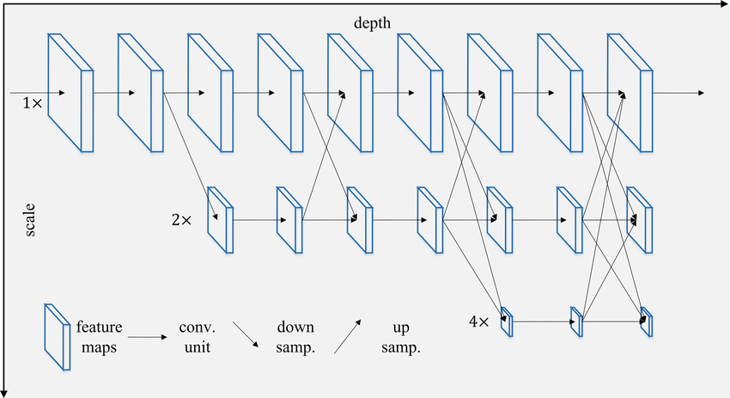

**2. Key Features of HRNet**

* **Parallel Multi-Scale Feature Extraction:** Unlike traditional CNNs that downsample images progressively, HRNet preserves high-resolution representations by maintaining parallel branches for different resolutions.
* **Fusion of Multi-Scale Features:** HRNet continuously exchanges information across different resolution streams to enhance feature learning.
* **Deep and Efficient Architecture:** The network is structured to ensure rich semantic information while retaining spatial accuracy.
* **State-of-the-Art Performance:** HRNet has outperformed many existing models in human pose estimation, semantic segmentation, and object detection benchmarks.

**3. Architecture of HRNet** HRNet follows a unique design where multiple resolution streams run in parallel and communicate at each stage:

* **Stem Network:** Initial convolutional layers to extract low-level features.
* **Parallel High-to-Low Resolution Convolutions:** Multiple streams with different resolutions processing simultaneously.
* **Repeated Multi-Scale Feature Fusion:** Information flows bidirectionally across different resolutions to maintain fine details.
* **Final Prediction Layers:** Fully connected or convolutional layers for classification, segmentation, or detection tasks.

**4. Advantages of HRNet**

* **Maintains High-Resolution Representations:** Unlike conventional models that lose spatial details due to aggressive downsampling, HRNet retains high-resolution information.
* **Superior Performance in Keypoint Detection:** HRNet is highly effective in human pose estimation and facial landmark detection.
* **Scalability:** The model can be adapted for various vision tasks with minimal modifications.
* **Better Segmentation and Detection Accuracy:** HRNet excels in pixel-wise classification tasks, such as semantic and instance segmentation.

**5. Applications of HRNet**

* **Human Pose Estimation:** Used in action recognition, healthcare monitoring, and sports analytics.
* **Semantic Segmentation:** Applied in autonomous driving, medical imaging, and aerial scene interpretation.
* **Object Detection:** Enhances accuracy in detecting small and occluded objects in real-world images.
* **Facial Landmark Detection:** Utilized in biometric recognition and emotion analysis.

**6. Conclusion** HRNet is a breakthrough CNN architecture that offers superior performance by preserving high-resolution representations throughout the network. Its ability to maintain spatial details while incorporating semantic richness makes it a valuable model for a wide range of computer vision tasks. Future research and improvements in HRNet could further enhance its efficiency and adaptability for real-world AI applications.